Name of speaker
Type of presentation: Invited ( ), Preferring Oral ( ), Preferring Poster ( ),
Oral only ( ) Poster only ( )
*Please check “V” in ( ).
IBS conference on Laser Plasma Accelerators

Hyung Taek Kim* and Chang Hee Nam

Department of Physics and Coherent X-ray Research Center, KAIST, Daejeon 305-701, Korea
*htkim@kaist.ac.kr

It is a great pleasure to invite you to the IBS Conference on Laser Plasma Accelerators [1], which will be held at Seogwipo-KAL hotel, Jeju island, Korea, from August 27 to September 1, 2017. This conference is the successive meeting of Laser Plasma Accelerator Workshop (LPAW) first held in Kardamili, Greece and recently held in Goa, India (2013) and Guadeloupe, French Caribbean Island (2015). Approximately 150 participants from the area of laser plasma accelerators will join in this workshop. The meeting also offers the opportunity to present the latest developments in laser and particle-beam drivers, novel accelerator concepts, diagnostics, high-field science, other particle sources, high-energy density plasmas and applications of next generation accelerators. In particular, five working groups will focus on: Laser wakefield accelerators, Plasma wakefield accelerator, Radiation generation, Ion acceleration, Theory and computation
The workshop will be sponsored mainly by Institute for Basic Science (IBS) as a series of “IBS conference”. The platform and style of the meeting will be the same as previous meetings. All of you are warmly invited to the workshop for presenting recent works and exchanging new research ideas on laser plasma accelerators.

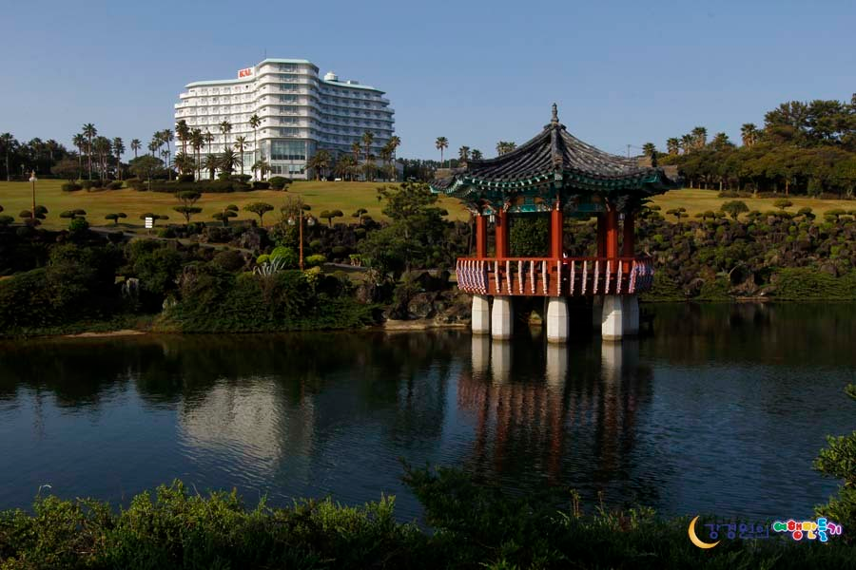
Figure 1. Seogwipo KAL hotel
References
[1] T. Tajima and J.M.Dawson, Phys. Rev. Lett. 43, 267 (1979).

