 |  | The 9th International Conference on Coherent Multidimensional Spectroscopy
 |  | June 26-29 Korea University, Seoul, South Korea
HOTEL RESERVATION FORM
The Shilla Seoul  249 Dongho-ro, Jung-gu, Seoul 04605, Korea  www.shilla.net/seoul |  |  |  |  | Contact: Steve Jeong, Sales Manager  Direct: +82-2-2230-3335 / Mobile: +82-10-2532-9686  Email: ych.jeong@samsung.com
Please fill out this Hotel Reservation Form and send it to the Sales Manager, Steve Jeong, via email.
The Shilla Seoul will issue a confirmation of your reservation upon receiving the reservation form and one night’s deposit.
H-1. PERSONAL INFORMATION
First Name |  |  |  |  |  |  | Last Name
Title (Mr/Ms/Dr/Prof) |  |  |  |  |  |  | Organization
Tel |  |  | Fax |  |  |  | E-mail
H-2. HOTEL RESERVATION
Please note that rooms will be allocated on a first-come, first-served basis with incoming request since the number of rooms is limited.
For early check-in and late check-out, extra charge will be made.
Hotel | Grade |  |  | Room Type |  | Rates (50~60% off room rate) |  |  | Inclusive
The Shilla  Hotel | Deluxe |  |  | □ Double  □ Twin |  | KRW 220,000 (approx. $206) |  |  | * Room Charges Only
 | Deluxe |  |  | □ Double  □ Twin |  | KRW 250,000 (approx. $234) |  |  | * Breakfast is included
 | Executive Business Deluxe |  |  | □ Double  □ Twin |  | KRW 350,000 (approx. $328) |  |  | * 23F Executive Lounge is included
 | Executive Grand Deluxe |  |  | □ Double |  | KRW 400,000 (approx. $375) |  |  | * 23F Executive Lounge is included
Check-in Date/ Time | □Early Check-in |  |  |  |  | Check-out Date/ Time |  | □ Late Check-out
Sharing with |  |  |  |  |  | Special Requests
H-3. Payment method (Please note that the card information will be used ONLY to guarantee your hotel reservation. No charge will be made to your credit card until you settle your accommodation bill when checking out.
Credit Card | □ Visa □ MasterCard □ Diners □ JCB □ AMEX
Card No. |  |  |  |  |  | Expiry Date  (MM/YYYY) |  | /
Card Holder’s Name |  |  |  |  |  | Signature
♦ NOTICE
Double occupancy charge: KRW 100,000 only for Executive Rooms
Additional Breakfast is available at KRW 30,000
10% service charge and 11% tax will be added to the room rates.
All fees will be calculated based on Korean Won (KRW).
The exchange rate for US$1.00 is approximately KRW 1,068 as of January 3, 2018.
Deadline for Hotel Reservations: May 29, 2018 (Reservations made after this date cannot be guaranteed.)
Cancellations must be received in writing by June 19, 2018. After June 19, 2018, the hotel will charge a cancellation fee which is equivalent to the entire duration of the room reservation period.

 | The 9th International Conference on Coherent Multidimensional Spectroscopy
 | June 26-29 Korea University, Seoul, South Korea
♦ HOTEL INFORMATION
The Shilla  249, Dongho-ro, Jung-gu, Seoul, 100-856, Korea  Tel: +82-2-2233-3131 / Website: www.shilla.net  As a member of the "Leading Hotels of the World(LHW)" drop, The Shilla Seoul fits an international standard of world renowned hotels. Praise from a long list of previous guest includes that of heads of state, government officials and leaders from various fields such as economics and culture. The Shilla Seoul also boasts accolades from prestigious media sources such as Conde Nast Traveler, Travel+Leisure, Zagat, and Euromoney. The Shilla offers relaxation, efficiency and satisfaction for CMDS 2018 participants. |  |  | 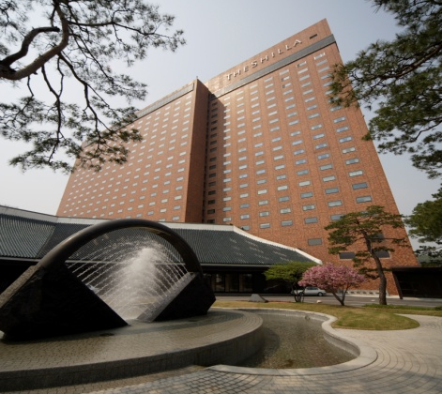
< Deluxe > KRW 220,000 (approx. $206)
Pleasant and comfortable
Space: 36 ㎡ / Beds: King, Twin
< Executive Business Deluxe > KRW 350,000 (approx. $328)
Designed for business and relaxation
Space: 43 ㎡ / Beds: King, Twin
< Executive Grand Deluxe > KRW 400,000 (approx. $375)
Offers the best view and the ultimate in relaxation
Space: 53 ㎡ / Beds: King

